The CDG2000 High Performance Transceiver (Part 3)

Post Mixer Amplifier

The post mixer amplifier follows the front end and apart from amplifying the signal to overcome the losses in the front end caused by the filters and the mixer, provides the main filtering for SSB and CW signals.

The circuit is shown in Figure 5. The 9MHz signal from the front end at 50 ohms is matched by T1 and applied to a quad FET amplifier stage TR1 to 4 providing about 14dB gain at a very low noise figure. The output at about 200 ohms is matched to the filters by T2 (to 50 ohms) and then to the filters by C9,10 and L1 (to 500 ohms) which is then routed via RLY2 and RLY1 which are switched along with RLY4 and RLY3 by TR5 to 8. The output is matched to 50 ohms by the L network L2, C19 and 20. The relay contacts are DC wetted as in the front end. This is essential to keep the relays functioning correctly at low signal levels. The effect of the 4 FETs is to raise the transconductance and when combined with the heavy feedback the effect is a high IP3 and low noise figure. The reason for the 50 ohm intermediate transformation after the FET amplifier before the filters is to provide a 50 ohm break point for testing.

At the moment, the overall IP3 performance of the whole receiver in CW is limited by the performance of this stage which is not quite as good as the IP3 figures for the front end. The problem is that the quad fet amplifier should show a very high IP3 - and indeed tests by many builders have shown this to be true. What we believe is happening however is that the non linear input impedance of the filter degrades the IP3. In tests, we found an amplifier output IP3 of +27 dBm, implying an input IP3 of +13dBm. The effect of this is to degrade performance - where the signals reaching the post mixer amplifier are large. Remember however that there is a high quality roofing filter on the Front End board. This means that the effect of poor IP3 is minimal in SSB and would only show itself in CW mode. Here, the overall performance of the receiver would be degraded to around +22dBm for a signal within the passband of the roofing filter ( i.e. about 1 kHz away). As Harold Johnson W4ZCB pointed out, most signals on the bands are not clean enough to mean that the receiver would be a limiting factor in this case.

Construction

This board is probably the easiest one in the transceiver to construct and should pose no problems. The component layout is shown in Figure 3 and the track layout in Figure 4. There are only six surface mounted components which are mounted on the track side and should be fitted first. The only other problems which are likely to arise are with the transformers T1 and T2.

T1 and T2 are constructed on Amidon balun cores BN-61-202 although BN-61-302 is an acceptable alternative. T2 is wound with 5 turns bifilar at about 5 turns per inch (25mm). Note the phasing of the winding. T1 has a secondary of one turn. Coaxial braid can be used for this with the primary wound through it or brass tubes can be fitted through each hole, connected together at one end and to ground and sources at the other as shown on the circuit diagram. Braid from RG174 (or if available silver plated equivalent) is ideal. The turns on L1 and L2 should occupy about 270 degrees of the toroid. A ferrite bead is slipped over the drain leg of each J310 before soldering to the track. The ferrite bead material is not critical – type 43 will do fine.

Testing

Check the operation of the relays with an ohmmeter by applying 12v to the relevant control pin to the pcb. A signal at 9 MHz should then be traced through the board and should emerge with about 10dB amplification when the SSB filter is selected. We tested the front end board together with this one at this stage by connecting the two boards together and applying a 0dBm signal from a signal generator to the LO input of the mixer, grounding a relevant pin of U3 to switch the band. Connecting an antenna to the front end and the output of the post mixer board to a receiver tuned to 9MHz should enable signals to be heard at the excellent performance of which this front end is capable. 7 MHz signals, for example, in the evening, will be a revelation. If you can tear yourself away at this stage, the rest of the receiver can be constructed.

The performance of the filters will typically be as detailed in Figure 1 and Figure 2. This was measured by connecting a digital power meter to the output of the post mixer amplifier unit and a signal generator to the input and recording the level every 100 Hz or so. The overall performance summary for one of the units was as follows

Amplifier gain | 14.2 dB
2.4 kHz filter insertion loss | 4.4 dB
250 Hz filter insertion loss | 11 dB

Components

The prototypes used filters manufactured by IQD, type 90H2.4B for the wide filter and 91H250 for the narrow filter. Testing on the prototypes yielded a very high IP3 for both filters with the CW filter surprisingly good at over +45 dBm. These are no longer manufactured although JAB [1] may still have limited supplies of the wide filter. A search of the Internet revealed two sources of 9 MHz filters, the first was found at Ten-Tec [2]. These ladder filters are available at several 6dB bandwidths, namely 2400, 1800, 500 and 250 Hz. The input and output impedances are both 200 ohms compared with 500 ohms for the IQD filters, and the matching networks will have to be changed. We tried the model 220 for 2400 Hz and model 217 for 500 Hz. The insertion loss is 2.2dB for the 2400Hz filter and 7.5 dB for the narrow. These losses are lower than the IQD filters by about 2 dB but the intercept point is not as good. Also, the centre frequency was slightly higher than 9 MHz and did not match the bandpass of the roofing filters. The obvious conclusion is that if these filters are used then similar filters (type 220) could also be used for the roofing filters on the front end board although this would seriously degrade the IP3 capability of the receiver. The second source was found at International Radio Corporation [3]. This firm manufacture replacement filters for most Amateur radios which are claimed to have superior performance to those originally supplied. We would suggest the use of reference 2310 for the wide filter and reference 2304 for the narrow. These filters have the same Zin / Zout as the IQD filters originally used and should need no change to the design. Failing the use of commercial filters, home made filters can be used. As a start, the roofing filters used in the front end can be copied and modified to cover the relevant passband. International Radio Corporation also supply kits for 9 MHz filters and we have obtained two of these with satisfactory, if not outstanding results. These are reference 350 and 351 which are each 4 pole. Two of these can be wired in series to produce 8 pole filters. The Zin / Zout is 200 ohms and some slight modification to the matching circuits would have to be made. The cost of the kits is roughly half that of manufactured filters. If DSP is to be incorporated, then the CW filter is perhaps not essential but is still desirable.

References

[1] JAB P.O. Box 5774, Birmingham B44 8PJ, telephone +44 (0)121 682 7045
[2] http://www.tentec.com
[3] http://www.qth.com/inrad

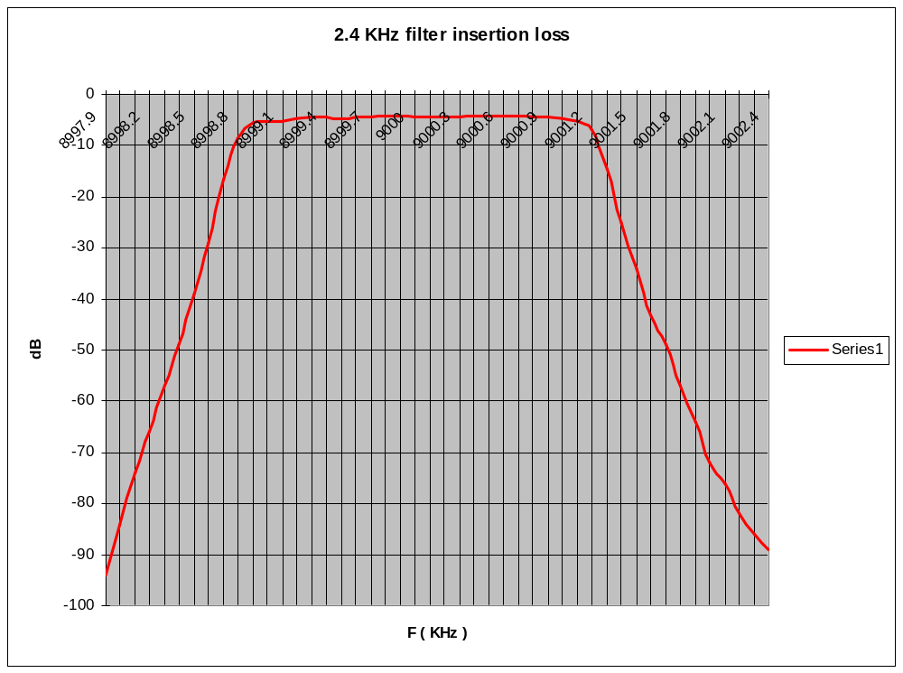
Figure 1 - Performance plot of 2.4 KHz filter

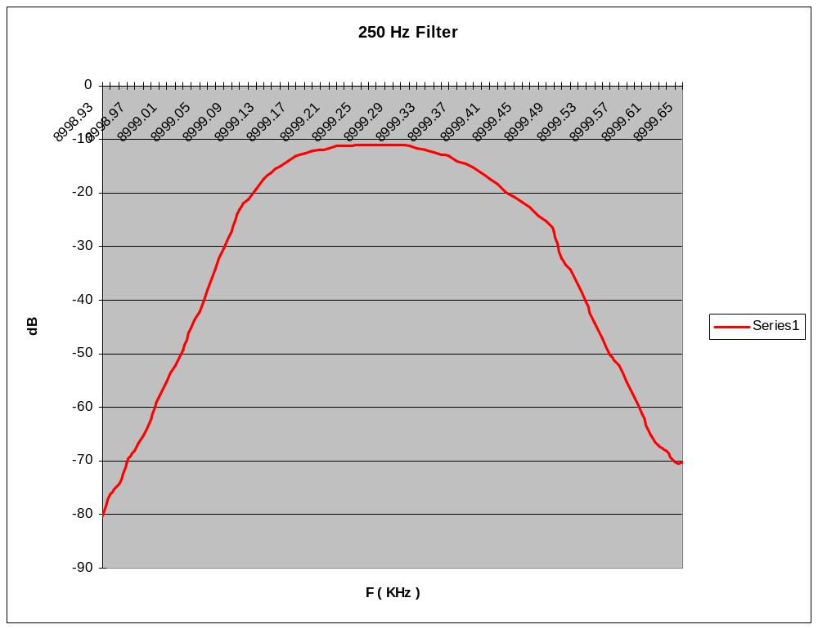
Figure 2 - performance plot of 250 Hz filter

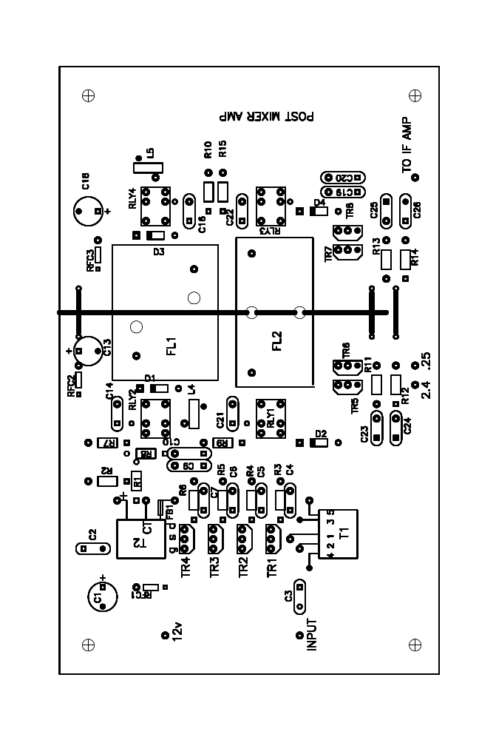

Figure 3 - component layout
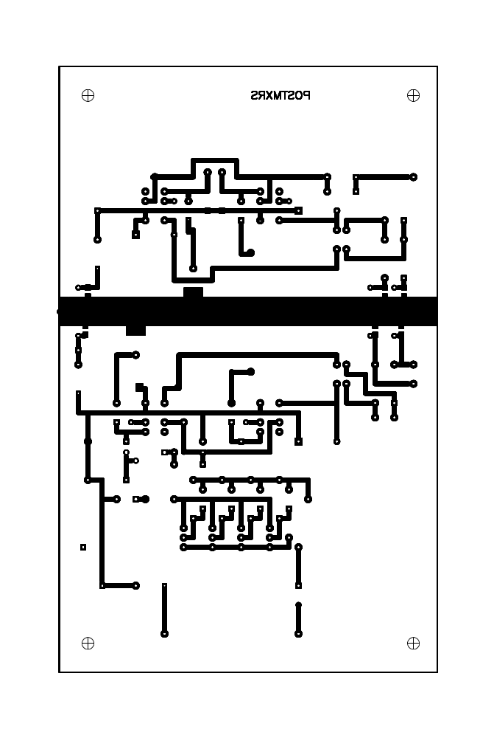
Figure 4 - PCB Tracking

COMPONENTS LIST – POST MIXER AMPLIFIER

Capacitors

100n multi layer ceramic C2,3,4,5,6,7,14,16,21,22,23,24,25,26
18p polystyrene C10,20
100p polystyrene C9,19
100n surface mount 0805 NPO (COG) C27,28,29,30,31,32
4u7 16v tantalum C1
10uF 16v tantalum C13,18

Resistors 0.25W metal film 1% MF25 series

18R R1,8R2,8
100R R3,4,5,6
75R R2
10K R11,12,13,14
22K R7,9,10,15

Inductors

Ferrite bead,type 43 FB1,2,3,4bead
Ferrite bead with 5t 0.315 enam RFC1,2,3
2.93uH 32t 0.315 enam on T37-6 toroid L1,2
4:1 transformer 5t bifilar on Amidon BN-61-202 T2
Transformer, pri 5t 0.315 enam, tap 4t from ground T1
sec 1t coax braid on BN-61-202

Semiconductors

J310 TR1,2,3,4
VN10KL TR5,6,7,8
1N4148 D1,2,3,4

Relays

SPCO RS 345 038 RLY1,2,3,4

Filters (see text)

IQD crystal filter 90H2.4B FL1
IQD crystal filter 91H250 FL2

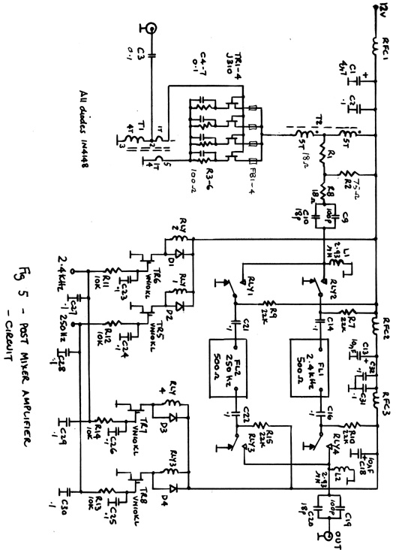

Figure 5 - Circuit Diagram

